Attorney Lookup

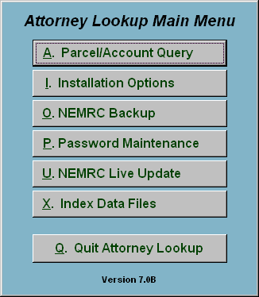
This is the Attorney Lookup Main Menu. The Attorney Lookup module is designed to allow for easy reporting on any Parcel/Account in Grand List, Tax Administration, Utility Billing, Accounts Receivable, and Land Records. The program will collect and report assessments, balances owed and transfer records. This can be done all at one time when customer numbers are uniform throughout all applications, otherwise the account for each module will need to be processed. Which of these modules this links to is defined in “I. Installation Options.”

